## Maulana Abul Kalam Azad University of Technology



**A Project submitted in partial fulfilment of**

**The requirement for the Honours Degree of**

**Bachelor of Computer Applications**

**Trippy**

( Tours and Travels )

**Paper Code: BCAD581**

**Year Of Examination: 2023-2024**

**Submitted by :**

| **Name** | **Roll Number** | **Registration Number** |
| --- | --- | --- |
| **Sourav Saha** | **26601221037** |  |
| **Supratim Das** | **26601221042** |  |
| **Somdipta Sen** | **26601221041** |  |
| **Shreyasi Dutta** | **26601221010** |  |

**Of**

**Bengal School of Technology and Management**

**SELF CERTIFICATE**

This is to certify that the dissertation / project report entitled ***Trippy*** is done by me, is an authentic work carried out for the partial fulfilment of the requirement for the award of the BCA under the guidance of Mrs. Sudipta Ghosh mam , Project Trainer, BSTM. I also certify that I am aware of the BCA project & project report standard 2022, issued by MAKAUT and this project report is based on that standard. The matter embodied in this project work has not been submitted earlier for award of any degree or diploma to the best of my knowledge and belief.

| **Name** | **Roll Number** | **Registration Number** |
| --- | --- | --- |
| **Sourav Saha** | **26601221037** |  |

**Of**

**Bengal School of Technology and Management**

**SELF CERTIFICATE**

This is to certify that the dissertation / project report entitled ***Trippy*** is done by me, is an authentic work carried out for the partial fulfilment of the requirement for the award of the BCA under the guidance of Mrs. Sudipta Ghosh mam , Project Trainer, BSTM. I also certify that I am aware of the BCA project & project report standard 2022, issued by MAKAUT and this project report is based on that standard. The matter embodied in this project work has not been submitted earlier for award of any degree or diploma to the best of my knowledge and belief.

| **Name** | **Roll Number** | **Registration Number** |
| --- | --- | --- |
| **Supratim Das** | **26601221042** |  |

**Of**

**Bengal School of Technology and Management**

**SELF CERTIFICATE**

This is to certify that the dissertation / project report entitled ***Trippy*** is done by me, is an authentic work carried out for the partial fulfilment of the requirement for the award of the BCA under the guidance of Mrs. Sudipta Ghosh mam , Project Trainer, BSTM. I also certify that I am aware of the BCA project & project report standard 2022, issued by MAKAUT and this project report is based on that standard. The matter embodied in this project work has not been submitted earlier for award of any degree or diploma to the best of my knowledge and belief.

| **Name** | **Roll Number** | **Registration Number** |
| --- | --- | --- |
| **Somdipta Sen** | **26601221041** |  |

**Of**

**Bengal School of Technology and Management**

**SELF CERTIFICATE**

This is to certify that the dissertation / project report entitled ***Trippy*** is done by me, is an authentic work carried out for the partial fulfilment of the requirement for the award of the BCA under the guidance of Mrs. Sudipta Ghosh mam , Project Trainer, BSTM. I also certify that I am aware of the BCA project & project report standard 2022, issued by MAKAUT and this project report is based on that standard. The matter embodied in this project work has not been submitted earlier for award of any degree or diploma to the best of my knowledge and belief.

| **Name** | **Roll Number** | **Registration Number** |
| --- | --- | --- |
| **Shreyasi Dutta** | **26601221010** |  |

**Of**

**Bengal School of Technology and Management**

##### **ACKNOWLEDGEMENT**

We feel immense pleasure to introduce ***Trippy***  as our minor project.

We would like to express our special thanks to our teacher Sudipta Ghosh , mam who has been a constant source of knowledge and inspiration to us, and who gave us the opportunity to do this project. We would also like to express our gratitude to our beloved parents for their review and many helpful comments and enlightening us and guiding us throughout the finalisation of this project within the limited time frame.

Last but not the least, we thank all our teachers and as well as friends who have given us that much strength to keep moving on forward every time. We are greatly thankful to the guidance of Mrs. Sudipta Ghosh mam , Project Trainer , BSTM college and all have no words to express our gratitude to them.

Finally, we would like to thank members of the BSTM family for their moral support and encouragement.

| **Name** | **Roll Number** | **Registration Number** |
| --- | --- | --- |
| **Sourav Saha** | **26601221037** |  |
| **Supratim Das** | **26601221042** |  |
| **Somdipta Sen** | **26601221041** |  |
| **Shreyasi Dutta** | **26601221010** |  |

**Trippy**

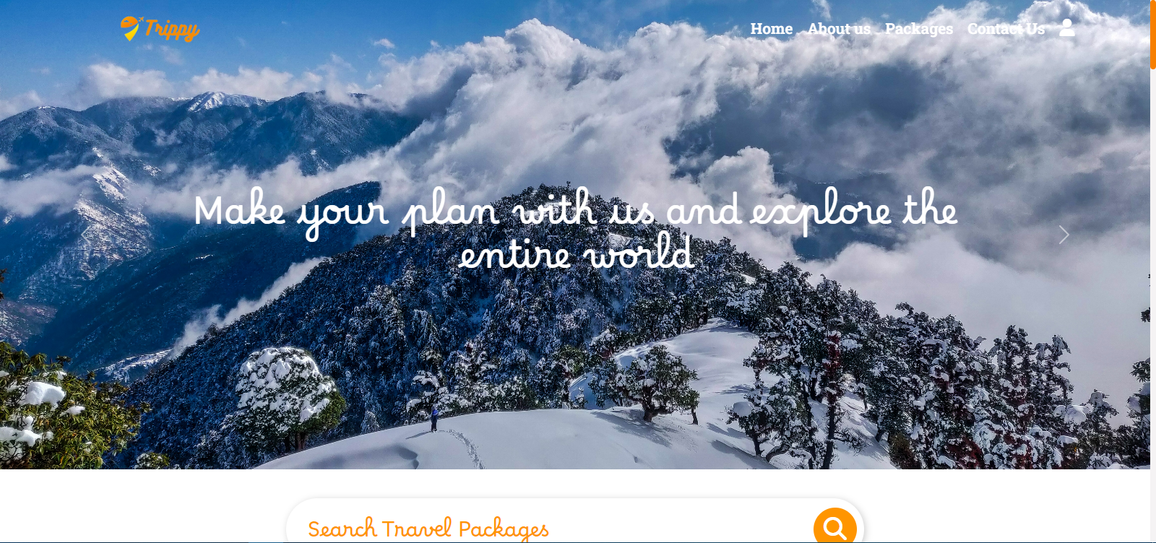

| Index | Topics | Page Number |
| --- | --- | --- |
| 1 | Introduction | 1 |
| 2 | Objective | 2 |
| 3 | Software Requirement Application | 3-19 |
| 4 | Software Development Tools | 20-21 |
| 5 | SDLC (Software Development Lifecycle) | 21-25 |
| 6 | System Project Planning | 26-27 |
| 7 | System Design | 27 |
| 8 | GANTT Chart | 29 |
| 9 | ERD & DFD | 30-33 |
| 10 | Snapshots Followed by Corresponding Code | 33-54 |
| 11 | Software Testing Technique & Maintenance | 55-57 |
| 12 | Future Scope of Project Work | 58 |
| 13 | Conclusion | 59 |
| 14 | Bibliography | 60 |

#### Introduction

Online Tour and Travel is a very user friendly project. In this project users can easily understand and book all packages and also register for hotels. In this project there are various types of forms, like all types of packages, book for package and Room Registration Page in which user can insert his personal needs & facilities then upload his form by which user can register in the web site. In this website users can also pay money through credit card.

This site provides different packages, destinations, and hotel booking services in one particular state of India. Himachal Pradesh is a very popular hill station of north India. Visitors enjoy snow covered mountain peaks and adventure sports like trekking, mountaineering and skiing.

In this website, according to the tour packages it provides services like online booking facilities for all packages and hotel registration to the customer. In this project users can easily understand and fill up the Room Reservation form. Users can search for various types of rooms.

Online Tour and Travel is a web based application made in Asp.Net. So with the help of this project users can apply for packages of tour and room reservation.

#### Objective Of Trippy :

The website has interactive design. Visitors can use a search function that is realized with the help of Elasticsearch technology and quickly matches with the users’ requests. Also, the navigation bar has categorised as well as Log In and Sign In. The interactive design improves the browsing experience.

This system provides Online Registration, Tour Package Information, ticket booking and all other destinations. The purpose of this project is very clear that user can find facilities easily & service providers also get good customers very easily. Customer can register on the website & can create his own registration then he can receive email for his status related to his reservation and book all packages.

The Main Goal of this project is to provide very fast booking services for different types of packages so any user can get this service very easily. Our objective is to make strong relationships with customers so that they can enjoy the holiday of their dreams.

**Admin:**

**Dashboard:** In this section, admin can see all details in brief like total number of packages, total booking details and also edit them.

**Add Packages:** In this section admin can add different packages

**User / Frontend Section:**

One time registration is required for a customer. Can review different packages and services from the home page

Home Page: Customers can visit the website and explore different packages.

Login: Customers can login using valid credentials only.

Signup: Customers have to create an account to explore and book packages.

Logout: Customers can logout from their account.

Software Tools Used :

### **SRS (Software Requirement**

**Specification)** –

Software Requirements Specification (SRS) is a document that specifies the requirements for a software system. It is a detailed description of the software that is being developed and includes information such as the functional requirements, performance requirements, design constraints, and other factors that need to be taken into consideration during the development process. The SRS is used as a reference point throughout the software development life cycle and helps to ensure that the final product meets the needs and expectations of the customer or end user. The SRS is typically created by a team of analysts who work closely with the customer to gather and document the requirements for the software. It is an important step in the software development process and helps to ensure that the final product is of high quality and meets the needs of the users.

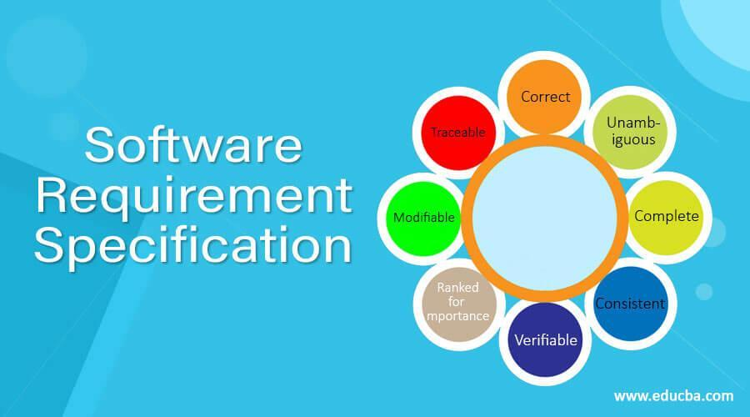

### **SDK(Software Development Kit) ---**

A software development kit (SDK) is a set of tools that provides a developer with the ability to build applications for a certain software platform. An SDK typically includes libraries, documentation, and sample code that a developer can use to create applications for a specific platform. It may also include tools for testing and debugging the application, as well as other resources that are useful for developing applications. SDKs are typically provided by the company that develops the software platform and are designed to make it easier for developers to build applications for that platform. There are many different SDKs available for a variety of software platforms, such as mobile operating systems, desktop operating systems, and web platforms.

The SDK which we have used in our project is -

### **XAMPP**

XAMPP is an open-source web server solution package. It is mainly used for web application testing on a localhost web server.

XAMPP stands for:

X = Cross-platform

A = Apache Server

M = MariaDB

P = PHP

P = Perl

Now that we have a better understanding of the XAMPP software, let us move on to its installation.

Why Do We Need XAMPP ?

To run any PHP program, you will need Apache or MYSQL databases, both supported by XAMPP. XAMPP helps you to run your program smoothly.

How to Install XAMPP?

Apache friends developed XAMPP, and it is available for everyone free of cost.

You can download XAMPP through the official website, <https://www.apachefriends.org/download.html>.

On completing the download of the setup file, begin the installation process and, in the “Select Components” section, select all the required components.

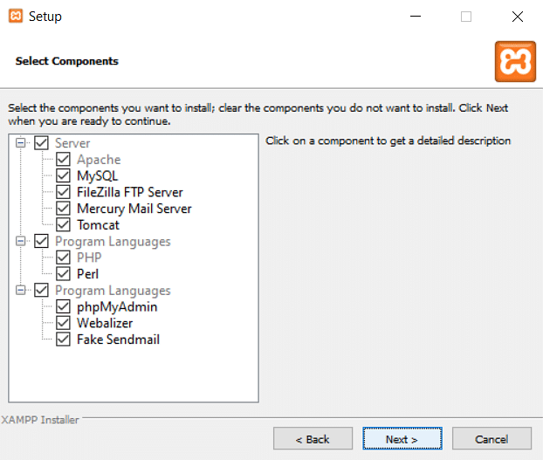

Next, select the directory where you want the software to be installed. It is recommended that you keep the default directory “C:\xampp” and click on “next” to complete the installation.

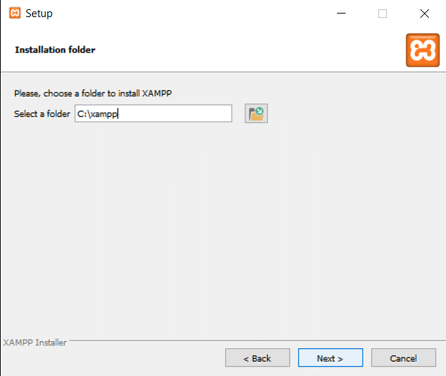

Now that the installation is complete, let’s move ahead to see how to run a PHP script using the same.

How to Start a New PHP Project in XAMPP?

* Before you run or start writing any program in PHP, you should start Apache and MYSQL.
* After starting both servers, you have to write a program in Notepad.
* After writing it, save that file as "program.php".
* Then copy that file program.php to C:/Program Files/XAMPP/htdocs.
* Open the browser and type [http://localhost](http://localhost/).
* Now run your code in that browser.

How to Run a PHP Code Using XAMPP?

Before running a PHP script, we must know where to write it. In the XAMPP directory, there exists a folder called “htdocs”. This is where all the programs for the web pages will be stored.

Now, to run a PHP script:

1. Go to “C:\xampp\htdocs” and inside it, create a folder. Let’s call it “demo”. It’s considered good practice to create a new folder for every project we will be working on.

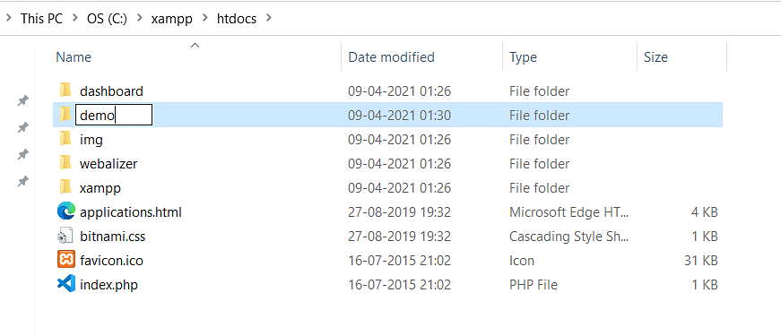

2. Inside the demo folder, create a new text file and name it “index.php” and write the following script.

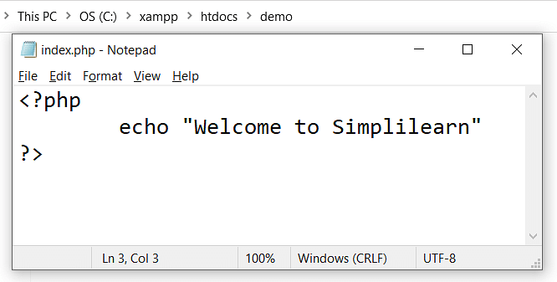

3. Now, to see the script output, open the XAMPP control panel and start Apache to host the local web server, where our script will be running.

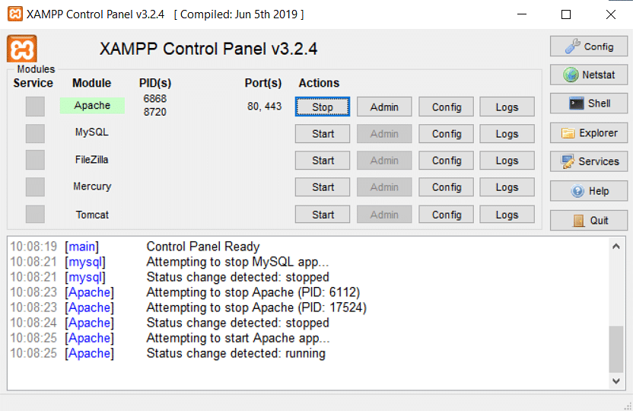

4. Now navigate to your browser and type in “localhost/demo/” in the address bar to view the output.

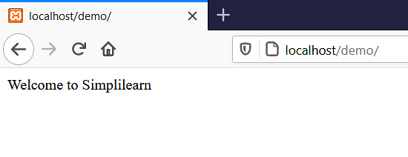

In this way we have created a PHP file and also executed the program successfully.

### **2. Visual Studio Code**

Visual Studio Code, also commonly referred to as VS Code, is a source-code editor made by Microsoft with the Electron Framework, for Windows, Linux and macOS. Features include support for debugging, syntax highlighting, intelligent code completion, snippets, code refactoring, and embedded Git. Users can change the theme, keyboard shortcuts, preferences, and install extensions that add functionality. Out of the box, Visual Studio Code includes basic support for most common programming languages. This basic support includes syntax highlighting, bracket matching, code folding, and configurable snippets. Visual Studio Code also ships with IntelliSense for JavaScript, TypeScript, JSON, CSS, and HTML, PHP as well as debugging support for Node.js. Support for additional languages can be provided by freely available extensions on the VS Code Marketplace.



### **3. My SQL Server**

MySQL is an [open-source](https://en.wikipedia.org/wiki/Open-source_software) [relational database management](https://en.wikipedia.org/wiki/Relational_database_management_system) [system](https://en.wikipedia.org/wiki/Relational_database_management_system) (RDBMS). Its name is a combination of "My", the name of co- founder [Michael Widenius](https://en.wikipedia.org/wiki/Michael_Widenius)'s daughter My, and "SQL", the acronym for [Structured Query Language](https://en.wikipedia.org/wiki/Structured_Query_Language). A [relational database](https://en.wikipedia.org/wiki/Relational_database) organises data into one or more data tables in which data may be related to each other; these relations help structure the data. SQL is a language programmers use to create, modify and extract data from the relational database, as well as control user access to the database. In addition to relational databases and SQL, an RDBMS like MySQL works with an [operating](https://en.wikipedia.org/wiki/Operating_system) [system](https://en.wikipedia.org/wiki/Operating_system) to implement a relational database in a computer's storage system, manages users, allows for network access and facilitates testing database integrity and creation of backups

MySQL is [free and open-source software](https://en.wikipedia.org/wiki/Free_and_open-source_software) under the terms of the [GNU](https://en.wikipedia.org/wiki/GNU_General_Public_License) General Public License, and is also available under a variety of [proprietary](https://en.wikipedia.org/wiki/Proprietary_software) licences. MySQL was owned and sponsored by the [Swedish](https://en.wikipedia.org/wiki/Sweden) company MySQL AB, which was bought by [Sun](https://en.wikipedia.org/wiki/Sun_Microsystems) [Microsystems](https://en.wikipedia.org/wiki/Sun_Microsystems) (now Oracle Corporation). In 2010, when [Oracle acquired](https://en.wikipedia.org/wiki/Acquisition_of_Sun_Microsystems_by_Oracle_Corporation) [Sun](https://en.wikipedia.org/wiki/Acquisition_of_Sun_Microsystems_by_Oracle_Corporation), Widenius [forked](https://en.wikipedia.org/wiki/Fork_(software_development)) the [open-source](https://en.wikipedia.org/wiki/Open-source) MySQL project to create [MariaDB](https://en.wikipedia.org/wiki/MariaDB).

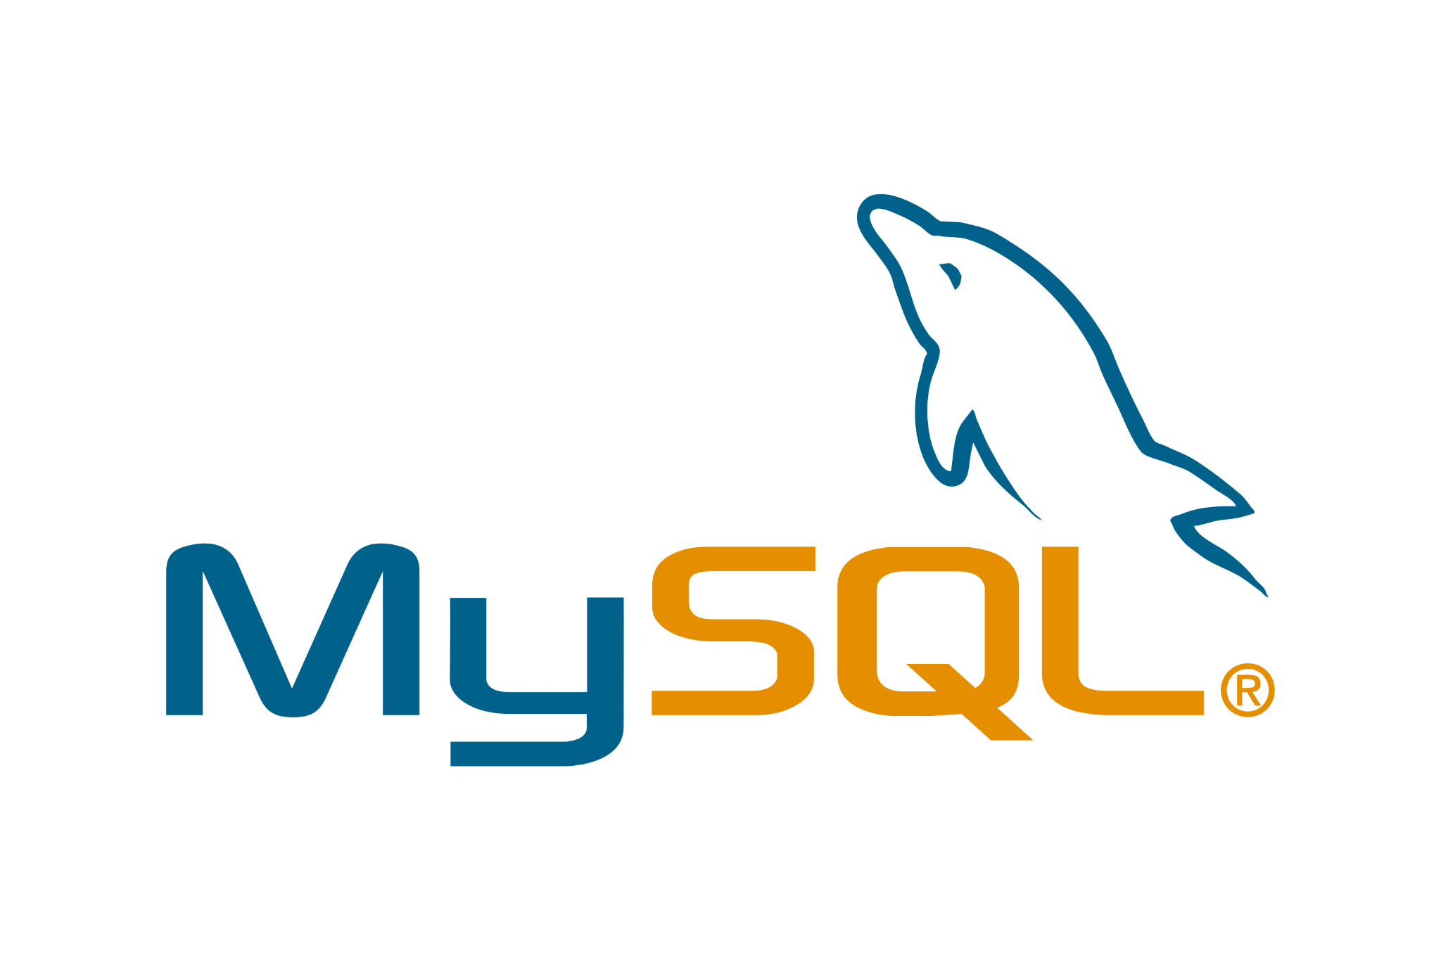

##### **4. Apache Server**

##### 

**Web Hosting**

Web hosting also known as website hosting or web hosting -- is the process where a web hosting provider stores and maintains website files and applications on a server to make its customers' websites accessible

##### **What is Domain ?**

When referring to an Internet address or name, a domain or domain name is the location of a website. For example, the domain name "google.com" points to the IP address "216.58.216.164". Generally, it's easier to remember a name rather than a long string of numbers. A domain name contains a maximum of sixty three characters, with one character minimum, and is entered after the protocol in the URL, as shown in the following example.

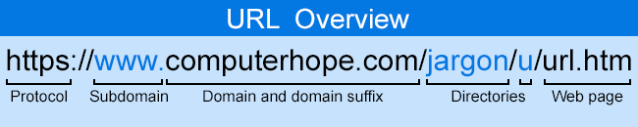

##### **Sub Domain**

A subdomain is a prefix added to a domain name to separate a section of your website. Site owners primarily use subdomains to manage extensive sections that require their own content hierarchy, such as online stores, blogs or support platforms. Subdomains function as a separate website from its domain.

**url:** <https://anorectal-projects.000webhostapp.com/>

**Sub-url :** https://anorectal-projects.000webhostapp.com/admin/login.php

is a subdomain.

## **HTML**



HTML is an acronym which stands for Hyper Text Markup Language which is used for creating web pages and web applications. Let's see what is meant by Hypertext Markup Language, and Web page.

HyperText: HyperText simply means "Text within Text." A text has a link within it, is a hypertext. Whenever you click on a link which brings you to a new webpage, you have clicked on a hypertext. HyperText is a way to link two or more web pages (HTML documents) with each other.

Markup language: A markup language is a computer language that is used to apply layout and formatting conventions to a text document. Markup language makes text more interactive and dynamic. It can turn text into images, tables, links, etc.

Web Page: A web page is a document which is commonly written in HTML and translated by a web browser. A web page can be identified by entering an URL. A Web page can be of the static or dynamic type. With the help of HTML only, we can create static web pages.

##### **CSS**



CSS is used to control the style of a web document in a simple and easy way. CSS is the acronym for "Cascading Style Sheet".

Cascading Style Sheet (CSS) is used to set the style in web pages that contain HTML elements. It sets the background color, font-size, font-family, color etc. properties of elements on a web page.

There are three types of CSS which are given below:

* Inline CSS
* Internal or Embedded CSS
* External CSS

Inline CSS : Inline CSS contains the [CSS](https://www.geeksforgeeks.org/css/) property in the body section attached to the element is known as inline CSS. This kind of style is specified within an HTML tag using the style attribute.

Internal or Embedded CSS : This can be used when a single HTML document must be styled uniquely. The CSS rule set should be within the HTML file in the head section i.e. the CSS is embedded within the <style> tag inside the head section of the HTML file.

External CSS : External CSS contains separate CSS files that contain only style properties with the help of tag attributes (For example class, id, heading, … etc). CSS property is written in a separate file with a .css extension and should be linked to the HTML document using a link tag. It means that, for each element, style can be set only once and will be applied across web pages.

##### **What is JavaScript?**

JavaScript, often abbreviated as JS, is a programming language that is one of the core technologies of the World Wide Web, alongside HTML and CSS. As of 2023, 98.7% of websites use JavaScript on the [client](https://en.wikipedia.org/wiki/Client_(computing)) side for webpage behaviour, often incorporating third-party libraries. All major web browsers have a dedicated JavaScript engine to execute the code on users' devices.

Javascript helps you create really beautiful and crazy fast websites. You can develop your website with a console like look and feel and give your users the best Graphical User Experience.

Great thing about Javascript is that you will find tons of frameworks and Libraries already developed which can be used directly in your software development to reduce your time to market .

##### 

##### What is Jquery ?

jQuery is a JavaScript library designed to simplify HTML DOM tree traversal and manipulation, as well as event handling, CSS animation, and Ajax. It is free, open-source software using the permissive MIT License.As of August 2022, jQuery is used by 77% of the 10 million most popular websites.] Web analysis indicates that it is the most widely deployed JavaScript library by a large margin, having at least 3 to 4 times more usage than any other JavaScript library.

jQuery's syntax is designed to make it easier to navigate a document, select DOM elements, create animations, handle events, and develop Ajax applications. jQuery also provides capabilities for developers to create plug-ins on top of the JavaScript library. This enables developers to create abstractions for low-level interaction and animation, advanced effects and high-level, theme-able widgets. The modular approach to the jQuery library allows the creation of powerful dynamic web pages and Web applications.

##### **What is Bootstrap?**



Bootstrap is a free and open-source tool collection for creating responsive websites and web applications. It is the most popular [HTML](https://www.geeksforgeeks.org/html/), [CSS](https://www.geeksforgeeks.org/css/),

and [JavaScript](https://www.geeksforgeeks.org/javascript/) framework for developing responsive, mobile-first websites. Nowadays, the websites are perfect for all browsers (IE, Firefox, and Chrome) and for all sizes of screens (Desktop, Tablets, Phablets, and Phones).

**Applications of Bootstrap**

* **Responsive Web Design**: Bootstrap empowers developers to create websites that seamlessly adapt to different screen sizes and devices, providing a consistent and optimal user experience.
* **Mobile-First Development**: Bootstrap’s mobile-first approach ensures that websites are designed and optimised for mobile devices, catering to the increasing usage of smartphones and tablets.

## **How to use Bootstrap on the webpage?**

There are two ways to include Bootstrap in the website.

1. **Include Bootstrap through CDN links**

<!-- Latest compiled and minified CSS -->

<link href="https://cdn.jsdelivr.net/npm/bootstrap@5.3.2/dist/css/bootstrap.min.css" rel="stylesheet">

<!-- Latest compiled JavaScript -->

<script src="<https://cdn.jsdelivr.net/npm/bootstrap@5.3.2/dist/js/bootstrap.bundle.min.js>"></script>

**Download Bootstrap from getbootstrap.com and use it:**

* Goto [www.getbootstrap.com](http://www.getbootstrap.com) and click Getting Started. Click on the Download Bootstrap button

**What is PHP ?**

PHP (recursive acronym for PHP: Hypertext Preprocessor) is a widely-used open source general-purpose scripting language that is especially suited for web development and can be embedded into HTML.

An example:

Example #1 An introductory example

*<!DOCTYPE html>*

*<html>*

*<head>*

*<title>PHP example</title>*

*</head>*

*<body>*

*<?php*

*echo "Hi, I'm a PHP script!";*

*?>*

*</body>*

*</html>*

Instead of lots of commands to output HTML (as seen in C or Perl), PHP pages contain HTML with embedded code that does "something" (in this case, output "Hi, I'm a PHP script!"). The PHP code is enclosed in special start and end processing instructions <?php and ?> that allow you to jump into and out of "PHP mode."

What distinguishes PHP from something like client-side JavaScript is that the code is executed on the server, generating HTML which is then sent to the client. The client would receive the results of running that script, but would not know what the underlying code was. You can even configure your web server to process all your HTML files with PHP, and then there's really no way that users can tell what you have up your sleeve.

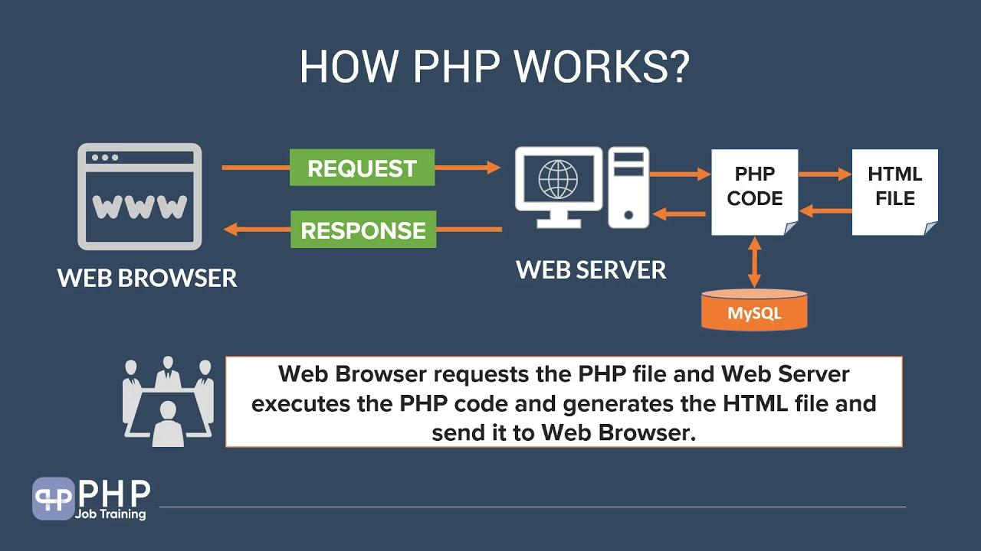

##### **What is SQL ?**

##### SQL is a language to operate databases; it includes Database Creation, Database Deletion, Fetching Data Rows, Modifying & Deleting Data rows, etc.

SQL stands for Structured Query Language which is a computer language for storing, manipulating and retrieving data stored in a relational database. SQL was developed in the 1970s by IBM Computer Scientists and became a standard of the American National Standards Institute (ANSI) in 1986, and the International Organization for Standardization (ISO) in 1987.

SQL is the standard language to communicate with Relational Database Systems. All the Relational Database Management Systems (RDMS) like MySQL, MS Access, Oracle, Sybase, Informix, Postgres and SQL Server use SQL as their Standard Database Language.



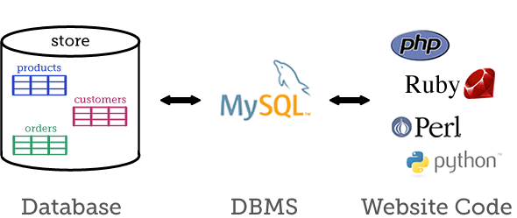

##### **What is FTP ?**

* FTP stands for File transfer protocol.
* FTP is a standard internet protocol provided by TCP/IP used for transmitting the files from one host to another.
* It is mainly used for transferring the web page files from their creator to the computer that acts as a server for other computers on the internet.
* It is also used for downloading the files to the computer from other servers.

##### **Feasibility Study**

A feasibility study evaluates a project's or system's practicality. As part of a feasibility study, the objective and rational analysis of a potential business or venture is conducted to determine its strengths and weaknesses, potential opportunities and threats, resources required to carry out, and ultimate success prospects. Two criteria should be considered when judging feasibility: the required cost and expected value.

###### **Types of Feasibility Study**

There are five types of feasibility study—separate areas that a feasibility study examines, described below.

1. **Technical Feasibility**

This assessment focuses on the technical resources available to the organisation. It helps organisations determine whether the technical resources meet capacity and whether the technical team is capable of converting the ideas into working systems. Technical feasibility also involves the evaluation of the hardware, software, and other technical requirements of the proposed system. As an exaggerated example, an organisation wouldn’t want to try to put Star Trek’s transporters in their building—currently, this project is not technically feasible

1. **Economic Feasibility**

This assessment typically involves a cost/ benefits analysis of the project, helping organisations determine the viability, cost, and benefits associated with a project before financial resources are allocated. It also serves as an independent project assessment and enhances project credibility—helping decision-makers determine the positive economic benefits to the organisation that the proposed project will provide

**3. Legal Feasibility**

This assessment investigates whether any aspect of the proposed project conflicts with legal requirements like zoning laws, data protection acts or social media laws. Let’s say an organisation wants to construct a new office building in a specific location. A feasibility study might reveal the organisation’s ideal location isn’t zoned for that type of business. That organisation has just saved considerable time and effort by learning that their project was not feasible right from the beginning.

**4. Operational Feasibility**

This assessment involves undertaking a study to analyse and determine whether—and how well—the organisation’s needs can be met by completing the project. Operational feasibility studies also examine how a project plan satisfies the requirements identified in the requirements analysis phase of system development.

1. **Scheduling Feasibility**

This assessment is the most important for project success; after all, a project will fail if not completed on time. In scheduling feasibility, an organisation estimates how much time the project will take to complete

**SDT(Software Development Tools)**

A software development tool is a program or application that is used to aid in the process of developing software. There are many different types of software development tools, and they can be used for a wide range of tasks, such as writing and editing code, debugging software, managing version control, and building and deploying software applications. Some common examples of software development tools include text editors, integrated development environments (IDEs), debugger tools, version control systems, and build automation tools. Software development tools can be used by individual developers or by teams of developers working on a software project. They are an essential part of the software development process and can help to improve efficiency and productivity.

The SDT which we have used in our project is:-

* 1. PHP
  2. Bootstrap4
  3. HTML
  4. CSS
  5. Javascript
  6. Jquery
  7. My

**Hardware Requirements**

* + - Processor: Minimum 1 GHz; Recommended 2GHz or more
    - Ethernet connection (LAN) OR a wireless adapter (Wi-Fi)
    - Hard Drive: Minimum 32 GB; Recommended 64 GB or more
    - Memory (RAM): Minimum 1 GB; Recommended 4 GB or above

##### **Software Requirements**

* Operating system : Windows 10 or above
* Coding Language : PHP 8.2

**SDLC(Software Development Life Cycle)** –

SDLC stands for "Software Development Life Cycle." It is a process that is followed for developing software systems. The SDLC process defines the steps that are involved in developing a software system, from the initial planning stages to the final deployment of the software. There are several different models that can be used to guide the SDLC process, each with its own set of steps and activities . Some common SDLC models include the Waterfall model, the Agile model, the Spiral model, and the V-shaped model

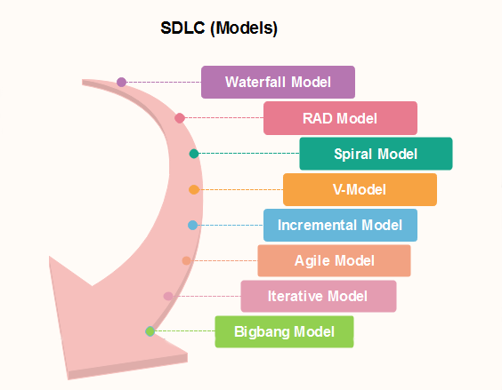

**Waterfall Model**

The Waterfall model is a linear model that follows a strict set of steps, with each step building upon the previous one. The Agile model is a flexible, iterative approach that allows for frequent changes and adaptations during the development process. The Spiral model is a risk- driven approach that involves iterative development and risk assessment. The V-shaped model is a combination of the Waterfall model and the Iterative model, with each step in the process followed in a linear fashion, but with the possibility of returning to earlier steps if necessary.

The waterfall is a universally accepted SDLC model. In this method, the whole process of software development is divided into various phases.

Linear ordering of activities has some significant consequences. First, to identify the end of a phase and the beginning of the next, some certification techniques have to be employed at the end of each step. Some verification and validation usually do this, that will ensure that the output of the stage is consistent with its input (which is the output of the previous step), and that the output of the stage is consistent with the overall requirements of the system.

##### [**Incremental Model in SDLC**](https://www.guru99.com/what-is-incremental-model-in-sdlc-advantages-disadvantages.html)

The incremental model is not a separate model. It is essentially a series of waterfall cycles. The requirements are divided into groups at the start of the project. For each group, the SDLC model is followed to develop software. The SDLC life cycle process is repeated, with each release adding more functionality until all requirements are met. In this method, every cycle acts as the maintenance phase for the previous software release. Modification to the incremental model allows development cycles to overlap. After that subsequent cycle may begin before the previous cycle is complete.

##### **Model in SDLC**

In this type of SDLC model testing and the development, the phase is planned in parallel. So, there are verification phases of SDLC on one side and the validation phase on the other side. V-Model joins by Coding phase.

##### [**Agile Model in SDLC**](https://www.guru99.com/agile-scrum-extreme-testing.html)

Agile methodology is a practice which promotes continued interaction of development and testing during the SDLC process of any project. In the Agile method, the entire project is divided into small incremental builds. All of these builds are provided in iterations, and each iteration lasts from one to three weeks.

**Big bang model**

The Big bang model is focusing on all types of resources in software development and coding, with no or very little planning. The requirements are understood and implemented when they come.

This model works best for small projects with smaller size development teams which are working together. It is also useful for academic software development projects. It is an ideal model where requirements are either unknown or final release date is not given.

###### [**RAD Model**](https://www.javatpoint.com/software-engineering-rapid-application-development-model)

RAD or Rapid Application Development process is an adoption of the waterfall model; it targets developing software in a short period. The RAD model is based on the concept that a better system can be developed in less time by using focus groups to gather system requirements.

* Business Modelling
* Data Modeling
* Process Modelling
* Application Generatio

##### 

##### 

##### **Spiral model**

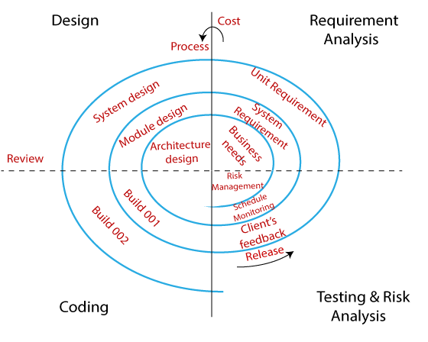

Why we are using Spiral SDLC model in our project -

The Spiral SDLC model is a risk-driven software development process model that is based on the idea of prototyping. In this model, the development process begins with a small set of requirements that are refined as the project progresses through multiple cycles, or "spirals." Each cycle consists of four phases: planning, risk analysis, engineering, and evaluation.

One of the main benefits of the Spiral model is that it allows for a high level of flexibility and iteration, which can be particularly useful in projects where requirements are not well-defined or are likely to change significantly over the course of the project. It can also be useful in projects where there are a lot of unknowns or high levels of risk, as it allows for a systematic approach to identifying and addressing these risks

Overall, the Spiral model can be a good choice for projects where a high level of collaboration and risk management is required, and where the development team needs to be able to adapt and respond to changing requirements as the project progresses.

##### **Software Project Planning :**

Project planning is an organised and integrated management process that focuses on the actions necessary for the project's practical completion. It avoids problems in the project, such as changes in the project's or organisation's objectives, resource shortages, and so forth. Project planning also aids in improved resource use, and the most efficient use of a project's allowed time. The following are the other project planning goals. Estimating the subsequent attributes of the project:

* + **Project size:**

What’s going to be downside quality in terms of the trouble and time needed to develop the product?

* + **Cost:**

What proportion is it reaching to value to develop the project?

* + **Duration:**

However long is it reaching to want complete development?

* + **Effort:**

What proportion effort would be required?

The effectiveness of the following designing activities relies on the accuracy of those estimations.

* + planning force and alternative resources
  + workers organisation and staffing plans
  + Risk identification, analysis, and abatement designing
  + Miscellaneous arrangements like quality assurance plan, configuration, management arrangement, etc

##### **System Design:**

System designis the process of designing the elements of a system such as the architecture, modules and components, the different interfaces of those components and the data that goes through that system.System Analysisis the process that decomposes a system into its component pieces for the purpose of defining how well those components interact to accomplish the set requirements.

There are several strategies that can be used to design software systems, including the following :

* 1. Top-Down Design : This strategy starts with a high-level view of the system and gradually breaks it down into smaller, more manageable components.
  2. Bottom-Up Design : This strategy starts with individual components and builds the system up, piece by piece.
  3. Iterative Design : This strategy involves designing and implementing the system in stages, with each stage building on the results of the previous stage.
  4. Incremental Design : This strategy involves designing and implementing a small part of the system at a time, adding more functionality with each iteration.
  5. Agile Design : This strategy involves a flexible, iterative approach to design, where requirements and design evolve through collaboration between self-organising and cross-functional teams.

**Gantt Chart**

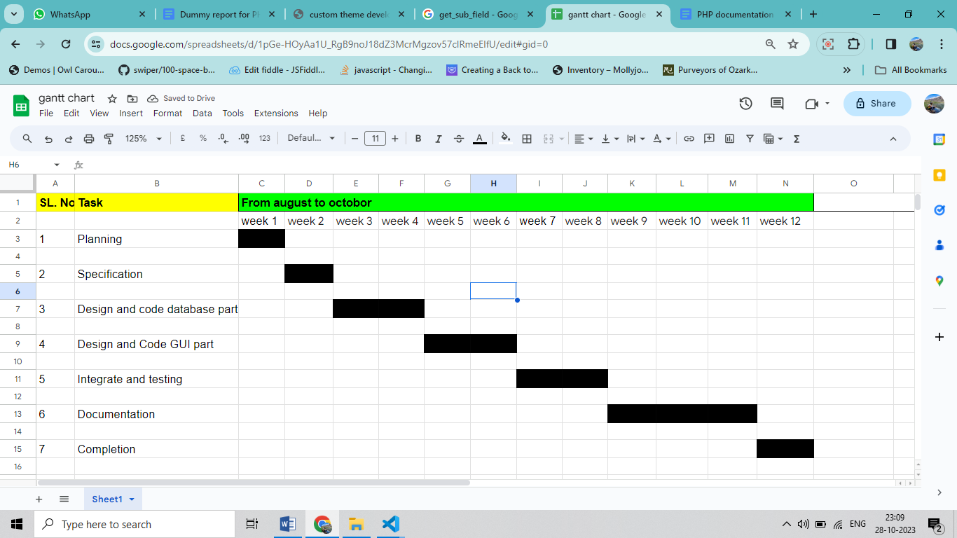

**ERD**

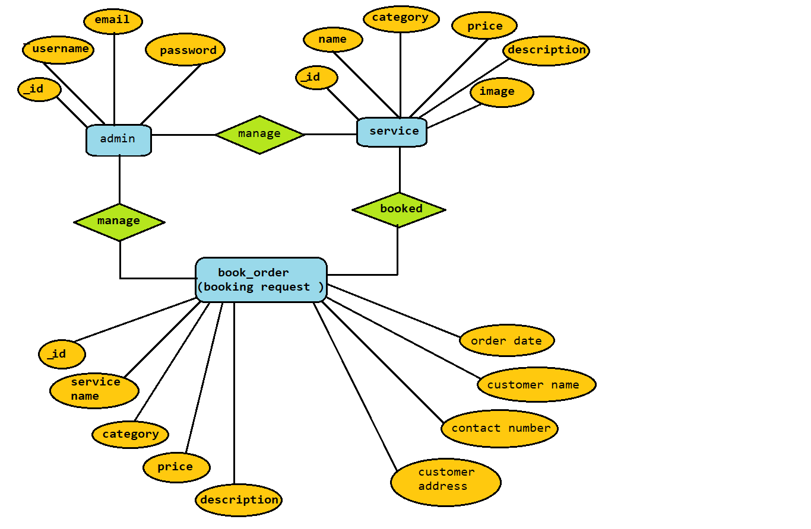

### **DFD (Data Flow Diagram)**

**0 level Admin DFD**

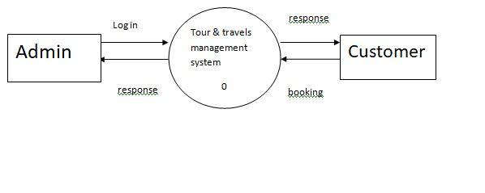

**1 level Admin DFD**

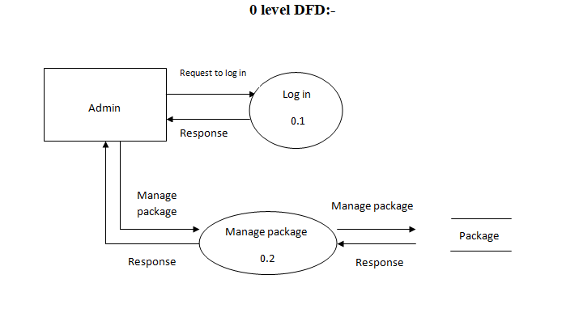

**2 level Admin DFD**

##### 

**1 level Customer** 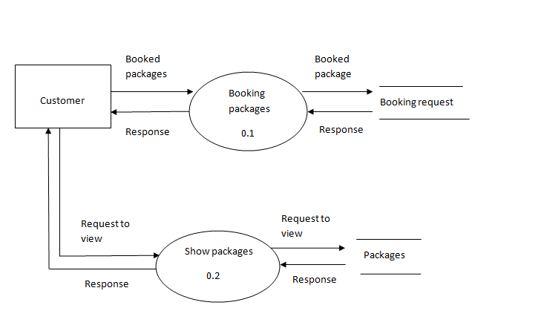

**Code :**

**Frontend :**

**home.php** **:**

<?php

session_start();

if($_SESSION['userid']=="" || !isset($_SESSION['userid'])) {

header("location:index.html");

}

?>

<!DOCTYPE html>

<html lang="en">

<head>

<meta charset="UTF-8">

<meta name="viewport" content="width=device-width, initial-scale=1.0">

<link rel="shortcut icon" href="image assets/logo.png" type="image/x-icon">

<link rel="stylesheet" href="css files/homestyle.css">

<link href="https://cdn.jsdelivr.net/npm/bootstrap@5.0.2/dist/css/bootstrap.min.css" rel="stylesheet"

integrity="sha384-EVSTQN3/azprG1Anm3QDgpJLIm9Nao0Yz1ztcQTwFspd3yD65VohhpuuCOmLASjC" crossorigin="anonymous">

<title>Trippy - Tour and Travels</title>

</head>

<body>

<nav>

<div class="main-nav">

<img src="image assets/logo.png" alt="">

<div class="navlinks" id="navlinks">

<ul>

<li><a href="home.php" class="links">Home</a></li>

<li><a href="about.html" class="links">About us</a></li>

<li><a href="allpackages.php" class="links">Packages</a></li>

<li><a href="contactus.html" class="links">Contact Us</a></li>

<li><a href="user profile/profile.php" class="profile"><i class="fa-solid fa-user"></i></a></li>

</ul>

</div>

<div href="#" class="toggle-btn" id="toggle-btn"><i class="fa-solid fa-bars"></i></div>

</div>

</nav>

<div id="carouselExampleFade" class="carousel slide carousel-fade" data-bs-ride="carousel"

style="position: relative; width: 100%;">

<div class="carousel-inner">

<div class="carousel-item active" data-bs-interval="10000">

<div class="carousel-caption d-block" style="position: absolute; top: 40%;">

<h1 style="font-family: 'Borel', cursive; text-align: center; font-size: 3.2rem;" class="shead">

Make your plan with us and explore the entire world

</h1>

</div>

<img src="image assets/beach silde.jpg" class="d-block w-100" alt="..."

style="height: 650px; object-fit: cover; object-position: center;">

</div>

<div class="carousel-item" data-bs-interval="2000">

<div class="carousel-caption d-block" style="position: absolute; top: 40%;">

<h1 style="font-family: 'Borel', cursive; text-align: center; font-size: 3.2rem;" class="shead">

Make your plan with us and explore the entire world

</h1>

</div>

<img src="image assets/ladakh slide.jpg" class="d-block w-100" alt="..."

style="height: 650px; object-fit: cover; object-position: center;">

</div>

<div class="carousel-item">

<div class="carousel-caption d-block" style="position: absolute; top: 40%;">

<h1 style="font-family: 'Borel', cursive; text-align: center; font-size: 3.2rem;" class="shead">

Make your plan with us and explore the entire world

</h1>

</div>

<img src="image assets/manali.jpg" class="d-block w-100" alt="..."

style="height: 650px; object-fit: cover; object-position: center;">

</div>

<div class="carousel-item">

<div class="carousel-caption d-block" style="position: absolute; top: 40%;">

<h1 style="font-family: 'Borel', cursive; text-align: center; font-size: 3.2rem;" class="shead">

Make your plan with us and explore the entire world

</h1>

</div>

<img src="image assets/valley slide.jpg" class="d-block w-100" alt="..."

style="height: 650px; object-fit: cover; object-position: bottom;">

</div>

</div>

<button class="carousel-control-prev" type="button" data-bs-target="#carouselExampleFade" data-bs-slide="prev">

<span class="carousel-control-prev-icon" aria-hidden="true"></span>

<span class="visually-hidden">Previous</span>

</button>

<button class="carousel-control-next" type="button" data-bs-target="#carouselExampleFade" data-bs-slide="next">

<span class="carousel-control-next-icon" aria-hidden="true"></span>

<span class="visually-hidden">Next</span>

</button>

</div>

<div class="search-section">

<form action="searchpack.php" id="search-bar" method="GET">

<input type="text" placeholder="Search Travel Packages" name="search_data">

<button type="submit" name='search'><i class="fa-solid fa-magnifying-glass"></i></button>

</form>

</div>

<div class="featured-section">

<h3>Featured Tours</h3>

<h2>Beautiful Places Around India</h2>

<div class="photo-grid">

<div id="first">

<img src="image assets/taj agra.jpg" alt="">

<h4>Agra</h4>

</div>

<div class="two-photos">

<div class="two-photo">

<img src="image assets/goa.jpg" alt="">

<h4>Goa</h4>

</div>

<div class="two-photo">

<img src="image assets/kashmir.jpg" alt="">

<h4>Kashmir</h4>

</div>

</div>

<div id="second">

<img src="image assets/ladakh7.jpg" alt="">

<h4>Ladakh</h4>

</div>

</div>

</div>

<div class="short-intro">

<div class="big-section">

<h4>Best Locations</h4>

<h1>Indian Tourism</h1>

</div>

<div class="small-section">

<p>With user-friendly tools, captivating destination descriptions, and secure booking options, our design

ensures a smooth and exciting travel planning experience. our platform has everything you need to

discover, plan, and book your Indian adventure with ease. </p>

</div>

</div>

<h1 class="package-heads">Top Seasional Destination Packages</h1>

<div class="card-container">

<a class="cards c1" href="seasional packages/summerpack.php">

<img src="image assets/summer.jpeg">

<p class="card-text">Summer</p>

</a>

<a class="cards c1" href="seasional packages/winterpack.php">

<img src="image assets/winter.jpg">

<p class="card-text">Winter</p>

</a>

<a class="cards c1" href="seasional packages/monsoonpack.php">

<img src="image assets/monsoon.jpg">

<p class="card-text">Monsoon</p>

</a>

<a class="cards c1" href="seasional packages/springpack.php">

<img src="image assets/spring.jpg">

<p class="card-text">Spring</p>

</a>

</div>

<h1 class="package-heads">Top Destination Packages</h1>

<div class="card-container">

<a class="cards c2" href="specialpackages.php?name=kashmir">

<img src="image assets/khasmir pic3.jpg">

<p class="card-text">kashmir</p>

</a>

<a class="cards c2" href="specialpackages.php?name=shimla">

<img src="image assets/shimla.jpg">

<p class="card-text">Shimla</p>

</a>

<a class="cards c2" href="specialpackages.php?name=goa">

<img src="image assets/goa.jpg">

<p class="card-text">Goa</p>

</a>

<a class="cards c2" href="specialpackages.php?name=jaipur">

<img src="image assets/jaipur.jpg">

<p class="card-text">Jaipur</p>

</a>

</div>

<h1 class="package-heads">Top Adventure Destination Packages</h1>

<div class="card-container">

<a class="cards c3" href="specialpackages.php?name=ladakh">

<img src="image assets/leh pic.jpg">

<p class="card-text">Leh ladakh</p>

</a>

<a class="cards c3" href="specialpackages.php?name=manali">

<img src="image assets/manali pic.jpg">

<p class="card-text">Manali</p>

</a>

<a class="cards c3" href="specialpackages.php?name=rishikesh">

<img src="image assets/rafting.jpg">

<p class="card-text">Rishikesh</p>

</a>

<a class="cards c3" href="specialpackages.php?name=andaman">

<img src="image assets/scuba diving.jpg">

<p class="card-text">Andaman</p>

</a>

</div>

<h1 class="package-heads">Top Religious Destination Packages</h1>

<div class="card-container">

<a class="cards c4" href="specialpackages.php?name=varanasi">

<img src="image assets/varanasi.jpg">

<p class="card-text">Varanasi</p>

</a>

<a class="cards c4" href="specialpackages.php?name=kedarnath">

<img src="image assets/kedarnath.webp">

<p class="card-text">Kedarnath</p>

</a>

<a class="cards c4" href="specialpackages.php?name=haridwar">

<img src="image assets/haridwar.jpg">

<p class="card-text">Haridwar</p>

</a>

<a class="cards c4" href="specialpackages.php?name=amritsar">

<img src="image assets/amritsar.jpg">

<p class="card-text">Amritsar</p>

</a>

</div>

<h1 class="package-heads">Top Wildlife Destination Packages</h1>

<div class="card-container">

<a class="cards c5" href="specialpackages.php?name=corbet">

<img src="image assets/jim corbet.jpg">

<p class="card-text">Jim corbet</p>

</a>

<a class="cards c5" href="specialpackages.php?name=kaziranga">

<img src="image assets/kaziranga.jpg">

<p class="card-text">Kaziranga</p>

</a>

<a class="cards c5" href="specialpackages.php?name=gir">

<img src="image assets/gir national park.jpg">

<p class="card-text">Gir National Park</p>

</a>

<a class="cards c5" href="specialpackages.php?name=sundarban">

<img src="image assets/sundarban.jpg">

<p class="card-text">Sundarban</p>

</a>

</div>

<h1 class="package-heads">Top South India Destination Packages</h1>

<div class="card-container">

<a class="cards c6" href="specialpackages.php?name=puducherry">

<img src="image assets/pondicherry.jpg">

<p class="card-text">Puducherry</p>

</a>

<a class="cards c6" href="specialpackages.php?name=karnataka">

<img src="image assets/karnataka.jpg">

<p class="card-text">Karnataka</p>

</a>

<a class="cards c6" href="specialpackages.php?name=kerala">

<img src="image assets/kerala 2.jpg">

<p class="card-text">Kerala</p>

</a>

<a class="cards c6" href="specialpackages.php?name=tamilnadu">

<img src="image assets/tamilnadu.jpg">

<p class="card-text">Tamilnadu</p>

</a>

</div>

<h1 class="package-heads">Top North East India Destination Packages</h1>

<div class="card-container">

<a class="cards c7" href="specialpackages.php?name=darjeeling">

<img src="image assets/darjeeling pic 1.jpg">

<p class="card-text">Darjeeling</p>

</a>

<a class="cards c7" href="specialpackages.php?name=meghalaya">

<img src="image assets/meghalaya.jpg">

<p class="card-text">Meghalaya</p>

</a>

<a class="cards c7" href="specialpackages.php?name=gangtok">

<img src="image assets/gangtok.jpg">

<p class="card-text">Gangtok</p>

</a>

<a class="cards c7" href="specialpackages.php?name=shillong">

<img src="image assets/shillong.jpg">

<p class="card-text">Shillong</p>

</a>

</div>

<div class="bottom-section container">

<div class="pic">

<img src="image assets/man bg.png" alt="">

</div>

<div class="pic-right">

<h1>Could not find your dream package ?</h1>

<p>Explore all packages here</p>

<a href="allpackages.php">Explore</a>

</div>

</div>

<footer>

<h1>Trippy</h1>

<div class="footer-links">

<h3>Support</h3>

<a href="about.html">About Us</a>

<a href="contactus.html">Contact Us</a>

<a href="contactus.html">Help Center</a>

<a href="#">Call Center</a>

</div>

<div class="footer-links">

<h3>Services</h3>

<a href="#">Hotels</a>

<a href="#">Trains</a>

<a href="#">Flights</a>

<a href="#">Cars</a>

</div>

<div class="footer-links">

<h3>Partners</h3>

<a href="https://www.irctc.co.in/">IRCTC</a>

<a href="https://www.goindigo.in/">INDIGO</a>

<a href="https://www.uber.com/in/en/">UBER</a>

<a href="https://www.redbus.in/">RED BUS</a>

</div>

</footer>

<script src="https://cdnjs.cloudflare.com/ajax/libs/gsap/3.12.2/gsap.min.js"

integrity="sha512-16esztaSRplJROstbIIdwX3N97V1+pZvV33ABoG1H2OyTttBxEGkTsoIVsiP1iaTtM8b3+hu2kB6pQ4Clr5yug=="

crossorigin="anonymous" referrerpolicy="no-referrer"></script>

<script src="https://cdnjs.cloudflare.com/ajax/libs/gsap/3.12.2/ScrollTrigger.min.js"

integrity="sha512-Ic9xkERjyZ1xgJ5svx3y0u3xrvfT/uPkV99LBwe68xjy/mGtO+4eURHZBW2xW4SZbFrF1Tf090XqB+EVgXnVjw=="

crossorigin="anonymous" referrerpolicy="no-referrer"></script>

<script src="https://cdn.jsdelivr.net/npm/bootstrap@5.0.2/dist/js/bootstrap.bundle.min.js"

integrity="sha384-MrcW6ZMFYlzcLA8Nl+NtUVF0sA7MsXsP1UyJoMp4YLEuNSfAP+JcXn/tWtIaxVXM"

crossorigin="anonymous"></script>

<script src="https://kit.fontawesome.com/e04331d407.js" crossorigin="anonymous"></script>

<script src="js files/homescript.js"></script>

</body>

</html>

###### **Add Package :**

<?php

session_start();

if($_SESSION['adminid']=="" || !isset($_SESSION['adminid'])) {

header("location:login.php");

}

?>

<!DOCTYPE html>

<html lang="en">

<head>

<meta charset="utf-8">

<meta http-equiv="X-UA-Compatible" content="IE=edge">

<meta name="viewport" content="width=device-width, initial-scale=1, shrink-to-fit=no">

<meta name="description" content="">

<meta name="author" content="">

<title>Package Form</title>

<!-- Custom fonts for this template-->

<link href="assets/vendor/fontawesome-free/css/all.min.css" rel="stylesheet" type="text/css">

<link

href="https://fonts.googleapis.com/css?family=Nunito:200,200i,300,300i,400,400i,600,600i,700,700i,800,800i,900,900i"

rel="stylesheet">

<!-- Custom styles for this template-->

<link href="assets/css/sb-admin-2.min.css" rel="stylesheet">

</head>

<body id="page-top">

<!-- Page Wrapper -->

<div id="wrapper">

<!-- Sidebar -->

<?php include("include/sidebar.php");?>

<!-- End of Sidebar -->

<!-- Content Wrapper -->

<div id="content-wrapper" class="d-flex flex-column">

<!-- Main Content -->

<div id="content">

<!-- Topbar -->

<?php include("include/topbar.php"); ?>

<!-- End of Topbar -->

<!-- Begin Page Content -->

<!-- /.container-fluid -->

<form action="insertpackage.php" method="post" enctype="multipart/form-data">

<h2>Fill package Details</h2>

<label for="Package Name">Package Name</label>

<p><input type="text" name="pname" placeholder="Enter package name" required class="form-control"></p>

<label for="Package Price">Package Price</label>

<p><input type="text" name="price" placeholder="Enter package price" required class="form-control"></p>

<label for="Day">Day of package</label>

<p><input type="number" name="day" placeholder="Enter day of package" required class="form-control"></p>

<label for="Day">Night of package</label>

<p><input type="number" name="night" placeholder="Enter night of package" required class="form-control"></p>

<label for="">Image for Package</label>

<p><input type="file" name="pimg" class="form-control"></p>

<label for="Day">Package Classification</label>

<p><input type="text" name="clf" placeholder="Enter classification of package" required class="form-control"></p>

<label for="category">Package Category</label>

<br>

<select name="category" class="form-control">

<option value="">Select Category</option>

<option value="standard">Standard</option>

<option value="premium">Premium</option>

</select>

<br>

<label for="location">Package Location</label>

<p><input type="text" name="location" placeholder="Enter location" required class="form-control"></p>

<label for="desc">Package Description</label>

<textarea name="desc" id="desc" cols="30" rows="10" class="form-control"></textarea>

<input type="submit" value="Submit Package">

</form>

</div>

<!-- End of Main Content -->

<!-- Footer -->

<?php include("include/footer.php") ?>

<script src="https://cdn.ckeditor.com/4.11.1/standard/ckeditor.js"></script>

<script>

CKEDITOR.replace('desc');

</script>

<script src="https://kit.fontawesome.com/e04331d407.js" crossorigin="anonymous"></script>

</body>

</html>

###### **List of Packages :**

<?php

session_start();

if($_SESSION['adminid']=="" || !isset($_SESSION['adminid'])) {

header("location:login.php");

}

?>

<!DOCTYPE html>

<html lang="en">

<head>

<meta charset="utf-8">

<meta http-equiv="X-UA-Compatible" content="IE=edge">

<meta name="viewport" content="width=device-width, initial-scale=1, shrink-to-fit=no">

<meta name="description" content="">

<meta name="author" content="">

<title>Package List</title>

<!-- Custom fonts for this template-->

<link href="assets/vendor/fontawesome-free/css/all.min.css" rel="stylesheet" type="text/css">

<link

href="https://fonts.googleapis.com/css?family=Nunito:200,200i,300,300i,400,400i,600,600i,700,700i,800,800i,900,900i"

rel="stylesheet">

<!-- Custom styles for this template-->

<link href="assets/css/sb-admin-2.min.css" rel="stylesheet">

<link rel="stylesheet" href="css files/liststyle.css">

</head>

<body id="page-top">

<!-- Page Wrapper -->

<div id="wrapper">

<!-- Sidebar -->

<?php include("include/sidebar.php");?>

<!-- End of Sidebar -->

<!-- Content Wrapper -->

<div id="content-wrapper" class="d-flex flex-column">

<!-- Main Content -->

<div id="content">

<!-- Topbar -->

<?php include("include/topbar.php"); ?>

<!-- End of Topbar -->

<!-- Begin Page Content -->

<form action="search.php" method="GET"

class="d-none d-sm-inline-block form-inline mr-auto ml-md-3 my-2 my-md-0 mw-100 navbar-search" id="search">

<div class="input-group">

<input type="text" class="form-control bg-light border-0 small" placeholder="Search Package Details .."

aria-label="Search" aria-describedby="basic-addon2" id="search-input" name="search" required>

<div class="input-group-append">

<button class="btn btn-primary" type="submit">

<i class="fas fa-search fa-sm"></i>

</button>

</div>

</div>

</form>

<!-- /.container-fluid -->

<table class="table table-success table-striped">

<thead>

<tr>

<th scope="col">Package Name</th>

<th scope="col">Package Price</th>

<th scope="col">Day</th>

<th scope="col">Night</th>

<th scope="col">Package Image</th>

<th scope="col">Classification</th>

<th scope="col">Category</th>

<th scope="col">Location</th>

<th scope="col">Package Description</th>

<th scope="col">Edit</th>

<th scope="col">Delete</th>

</tr>

</thead>

<tbody>

<?php

$connect=mysqli_connect("localhost","root","","tour_and_travels");

$row="SELECT * FROM package_info";

$res=$connect->query($row);

while($line=$res->fetch_assoc()){

?>

<tr>

<td><?php echo $line['package_name'] ?></td>

<td><?php echo $line['package_price'] ?></td>

<td><?php echo $line['day'] ?></td>

<td><?php echo $line['night'] ?></td>

<td><img src="package images/<?php echo $line['package_image']; ?>" style="width: 120px;" alt=""></td>

<td><?php echo $line['classification'] ?></td>

<td><?php echo $line['category'] ?></td>

<td><?php echo $line['location'] ?></td>

<td><a href="packageDescription.php?id=<?php echo $line['id'];?>" class="btn btn-primary">Details</a></td>

<td><a href="editlist.php?id=<?php echo $line['id'];?>" class="btn btn-primary"><i class="fa-solid fa-pen-to-square"></i></a></td>

<td><a href="delete.php?id=<?php echo $line['id'];?>" class="btn btn-danger" onclick="return confirm('Are you want to delete this data ?');"><i class="fa-solid fa-trash-can"></i></a></td>

</tr>

<?php

} ?>

</tbody>

</table>

</div>

<!-- End of Main Content -->

<!-- Footer -->

<?php include("include/footer.php") ?>

<script src="https://kit.fontawesome.com/e04331d407.js" crossorigin="anonymous"></script>

</body>

</html>

###### **List of Bookings :**

<?php

session_start();

if($_SESSION['adminid']=="" || !isset($_SESSION['adminid'])) {

header("location:login.php");

}

?>

<!DOCTYPE html>

<html lang="en">

<head>

<meta charset="utf-8">

<meta http-equiv="X-UA-Compatible" content="IE=edge">

<meta name="viewport" content="width=device-width, initial-scale=1, shrink-to-fit=no">

<meta name="description" content="">

<meta name="author" content="">

<title>Package List</title>

<!-- Custom fonts for this template-->

<link href="assets/vendor/fontawesome-free/css/all.min.css" rel="stylesheet" type="text/css">

<link

href="https://fonts.googleapis.com/css?family=Nunito:200,200i,300,300i,400,400i,600,600i,700,700i,800,800i,900,900i"

rel="stylesheet">

<!-- Custom styles for this template-->

<link href="assets/css/sb-admin-2.min.css" rel="stylesheet">

<link rel="stylesheet" href="css files/liststyle.css">

</head>

<body id="page-top">

<!-- Page Wrapper -->

<div id="wrapper">

<!-- Sidebar -->

<?php include("include/sidebar.php");?>

<!-- End of Sidebar -->

<!-- Content Wrapper -->

<div id="content-wrapper" class="d-flex flex-column">

<!-- Main Content -->

<div id="content">

<!-- Topbar -->

<?php include("include/topbar.php"); ?>

<!-- End of Topbar -->

<!-- Begin Page Content -->

<!-- <form action="search.php" method="GET"

class="d-none d-sm-inline-block form-inline mr-auto ml-md-3 my-2 my-md-0 mw-100 navbar-search" id="search">

<div class="input-group">

<input type="text" class="form-control bg-light border-0 small" placeholder="Search Package Details .."

aria-label="Search" aria-describedby="basic-addon2" id="search-input" name="search" required>

<div class="input-group-append">

<button class="btn btn-primary" type="submit">

<i class="fas fa-search fa-sm"></i>

</button>

</div>

</div>

</form> -->

<!-- /.container-fluid -->

<table class="table table-success table-striped">

<thead>

<tr>

<th scope="col">Package ID</th>

<th scope="col">Package Name</th>

<th scope="col">Package Price</th>

<th scope="col">Tourist Number</th>

<th scope="col">Date</th>

<th scope="col">Contact No</th>

<th scope="col">Travellers Name</th>

<th scope="col">Travellers Age</th>

<th scope="col">User ID</th>

<th scope="col">Payment ID</th>

</tr>

</thead>

<tbody>

<?php

$connect=mysqli_connect("localhost","root","","tour_and_travels");

$row="SELECT * FROM bookings_info";

$res=$connect->query($row);

while($line=$res->fetch_assoc()){

?>

<tr>

<td><?php echo $line['id'] ?></td>

<td><?php echo $line['package_name'] ?></td>

<td><?php echo $line['package_price'] ?></td>

<td><?php echo $line['tourist_number'] ?></td>

<td><?php echo $line['date'] ?></td>

<td><?php echo $line['contact_no'] ?></td>

<td><?php echo $line['traveller_name'] ?></td>

<td><?php echo $line['traveller_age'] ?></td>

<td><?php echo $line['user_id'] ?></td>

<td><?php echo $line['payment_id'] ?></td>

</tr>

<?php

} ?>

</tbody>

</table>

</div>

<!-- End of Main Content -->

<!-- Footer -->

<?php include("include/footer.php") ?>

<script src="https://kit.fontawesome.com/e04331d407.js" crossorigin="anonymous"></script>

</body>

</html>

##### **Screenshots followed by corresponding code :**

**Home page**

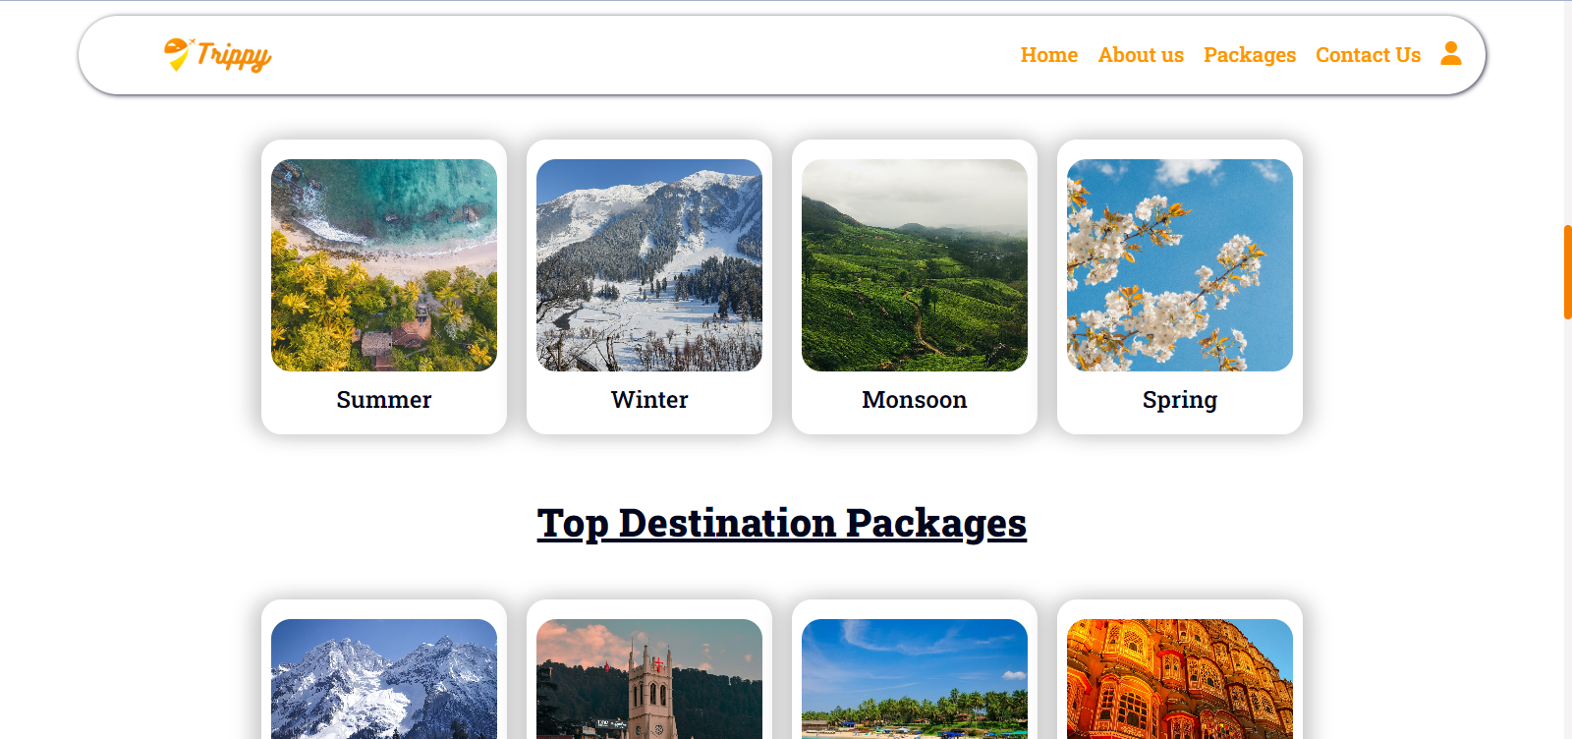

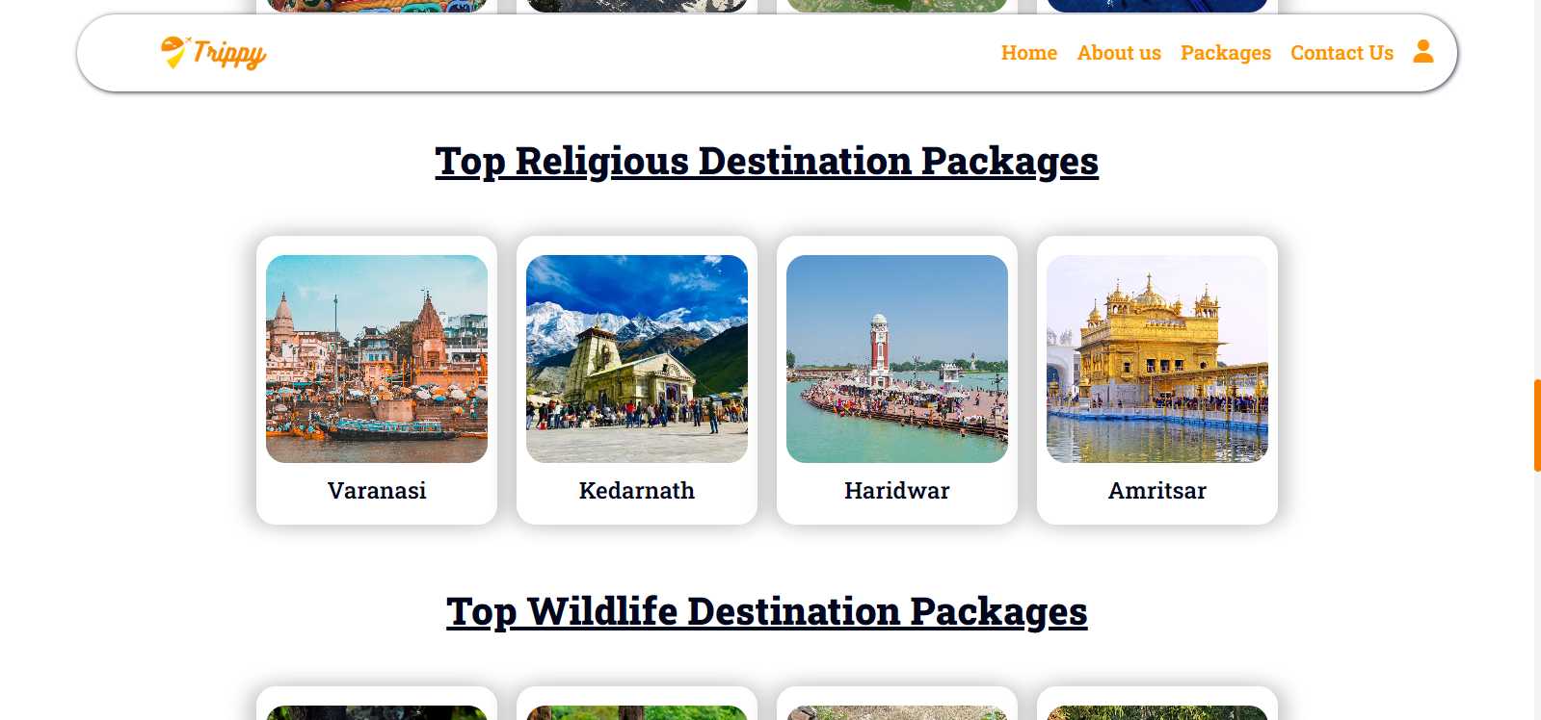

##### 

|  |  |
| --- | --- |

Admin :

Add Packages

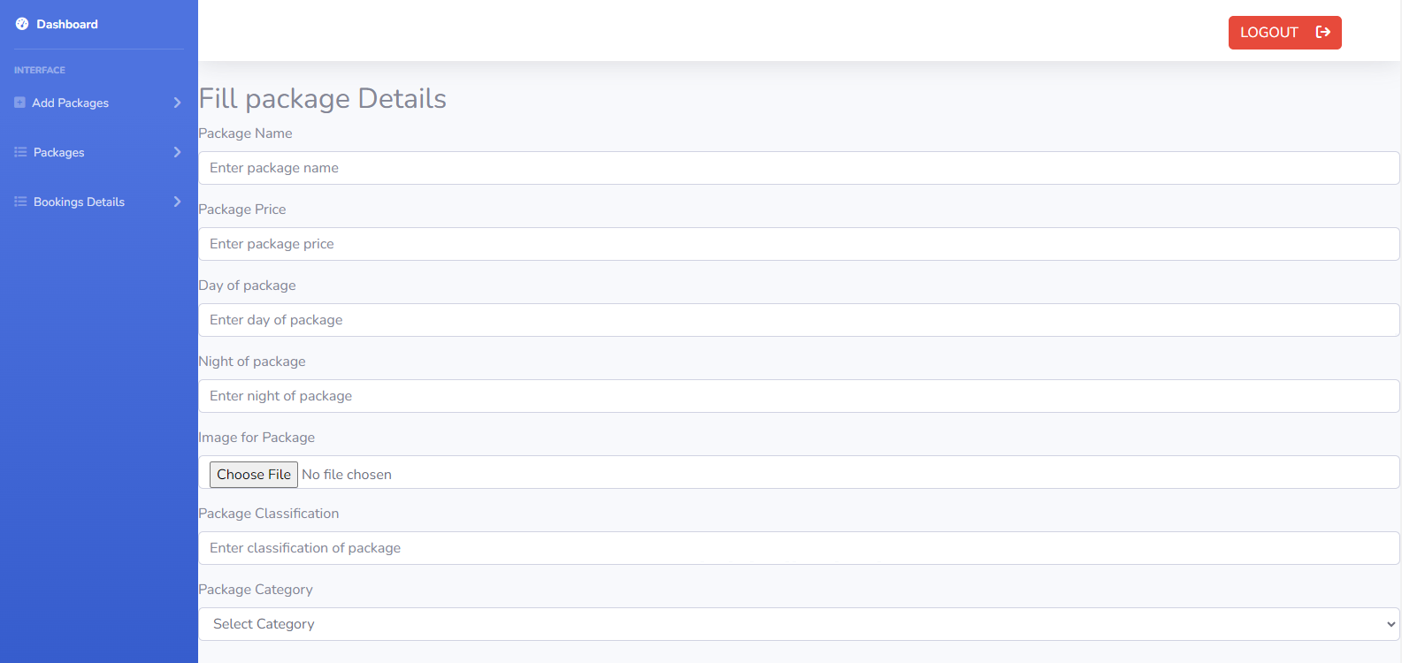

##### **List Services**

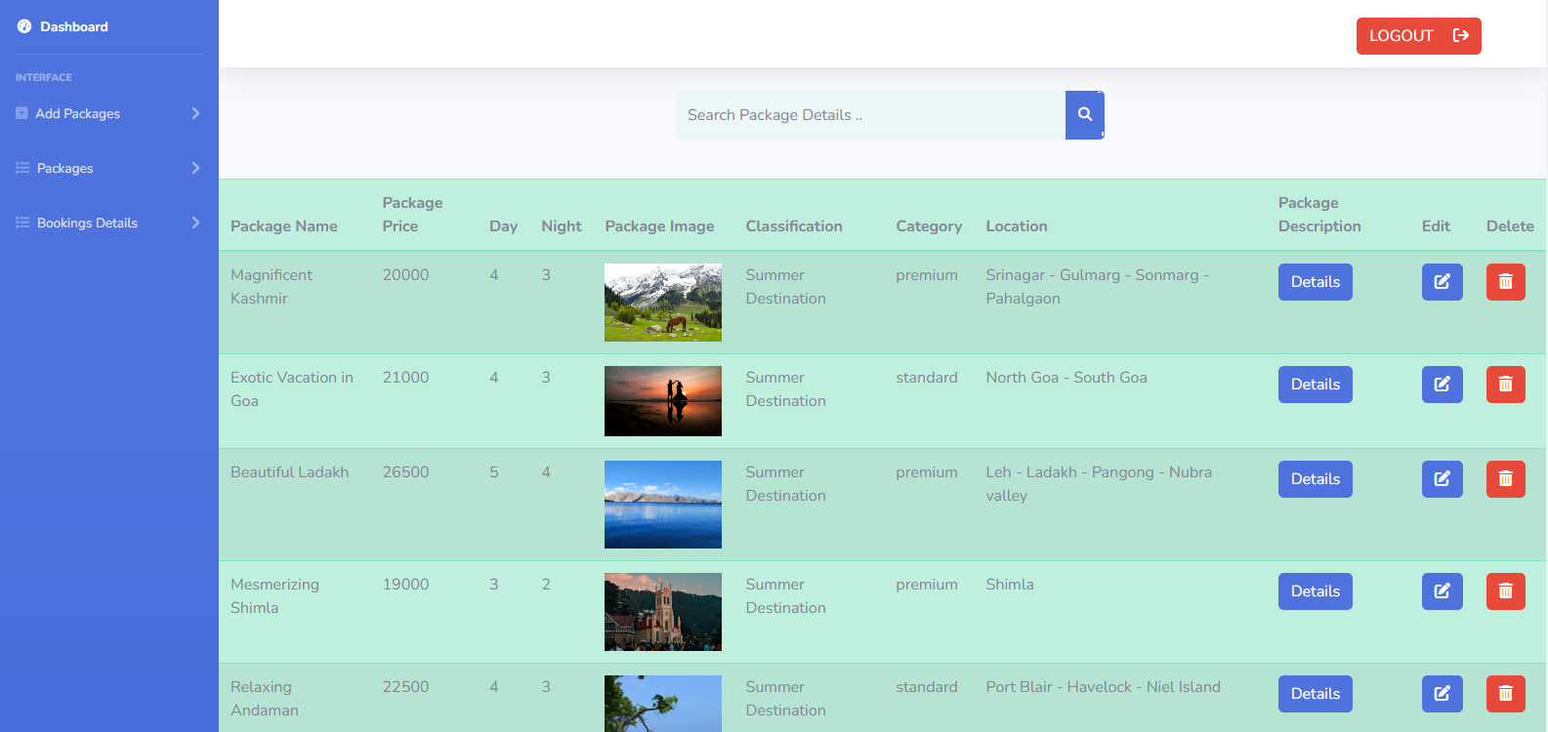

**Service Order**

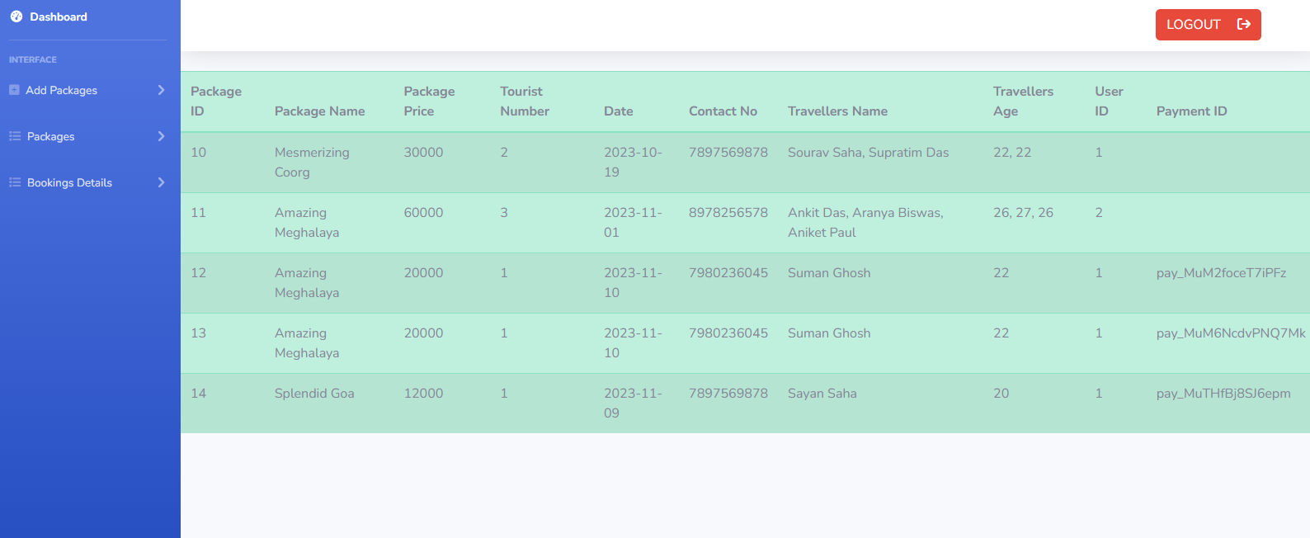

##### **Software Testing Techniques:**

The categorization of software testing is a part of diverse testing activities, such as **test strategy, test deliverables, a defined test objective, etc**. And software testing is the execution of the software to find defects.A strategy for software testing must accommodate low-level tests that are necessary to verify that a small source code segment can be correctly implemented as well as high –level tests that validate major system functions against customer requirements.

Types of Testing

1. Alpha Testing: -

Testing after code is mostly complete or contains most of the functional and prior to the end user being involved. More often this testing will be performed in house or by an outside testing firm in close cooperation with the software engineering department.

1. Beta Testing: -

Testing after the product is code complete. Betas are often widely distributed or even distributed to the public at large in hopes that they will buy the final product when it is released.

1. Functional Testing: -

Testing two or more modules together with the intent of finding defects, demonstrating that defects are not present, verifying that the modules performs its intended functions as stated in the specification and establishing confidence that a program does what it is supposed to do.

1. Configuration Testing: -

Testing to determine how well the product works with a broad of the hardware/peripheral equipment configurations as on the different operating systems and software.

1. Pilot Testing: -

Testing that involves the users just before actual release to ensure that users become familiar with the release contents and ultimately accept it. Typically involves many users, is conducted over a short period of time and is tightly controlled.

1. System Integration Testing: -

Testing a specific hardware/software installation. This is typically performed on a COTS system or any other system comprising the disparate parts where custom configurations and /or unique installation are the norm .

1. Software Testing: -

The process of exercising software is with the intent of ensuring that the software system meets its requirements and the user expectations and doesn’t file in an unacceptable manner .

1. Security testing: -

Testing of database and network software in order to keep company data and resources from mistaken/ accidental users, hackers and other malevolent attackers.

1. Installation Testing: -

Testing with the intent of determining if the product will install on a variety of platforms and how easily it instals .

1. Compatibility Testing: -

Testing used to determine whether other system software components such as browsers, utilities and competing software would conflict with the software being tested.

# **Maintenance**

The maintenance of existing software can account for over 60 percent of all effort expended by development organisations and the percentage continues to rise as more software is produced. There are four different kinds of maintenance:

1. **Corrective maintenance**: Corrective maintenance changes the software to correct defects.
2. **Adaptive maintenance**: Adaptive maintenance results in modifications to the software to accommodate changes to its external environment.
3. **Perfective maintenance**: Perfective maintenance extends the software beyond its original functional requirements.
4. **Preventive maintenance**: Preventive maintenance often called software reengineering must be conducted to enable software to serve the needs of its end users. In essence preventive maintenance makes changes to computer programs so that they can be more easily corrected, adopted and enhanced.

The following software is designed into modules (having well defined inputs, outputs and non-overlapping specific usage) – which makes it easier to maintain. Suppose a correction or perfection to the code is made due to user requirement; the effect remains within the particular module; the rest of the software remains intact

# **Future Scope of system**

* + Like I mentioned earlier, full integration of open source tools is critical in creating a seamless overall application. There are some ways in which Web Calendar was not integrated which I would like to pursue given more time.
  + We can give more advance software for Travel Website including more facilities
  + Integrate multiple load balancers to distribute the loads of the system
  + Implement the backup mechanism for taking backup of codebase and database on regular basis on different servers
  + We will try to provide more Tours and Travel Packages so that users get what they need. This system will try to add more new features. We will try to provide a more user-friendly interface in the future .

**Project URL :**

Frontend : <https://anorectal-projects.000webhostapp.com/>

Admin login : <https://anorectal-projects.000webhostapp.com/admin/login.php>

# **Conclusion**

Our project is only a humble venture to satisfy the needs to manage their project work. Several user-friendly coding have also been adopted. This package shall prove to be a powerful package in satisfying all the requirements . The objective of software planning is to provide a framework that enables the manager to make reasonable estimates made within a limited time frame at the beginning of the software project and should be updated regularly as the project progresses.

In the end it is concluded that we have made effort on following points...

• A description of the background and context of the project and its relation to work already done in the area.

• Made statement of the aims and objectives of the project

•The description of Purpose, Scope, and applicability

• We define the problem on which we are working in the project.

• We describe the requirement Specifications of the system and the actions that can be done on these things.

• We understand the problem domain and produce a model of the system, which describes operations that can be performed on the system.

• We included features and operations in detail, including screen layouts

• We designed user interfaces and security issues related to system.

• Finally the system is implemented and tested according to test cases.

##### **BIBLIOGRAPHY**

For successfully completing my Project , I have taken help from some websites and books. During the development of the assignment I have used the following books and websites links.

References :

1. <https://www.apachefriends.org/>
2. <https://www.mysql.com/>
3. <https://www.tutorialspoint.com/php/index.htm>
4. <https://www.php.net/>
5. <https://www.w3schools.com/bootstrap5/>
6. <https://www.yatra.com/>
7. <https://unsplash.com/>